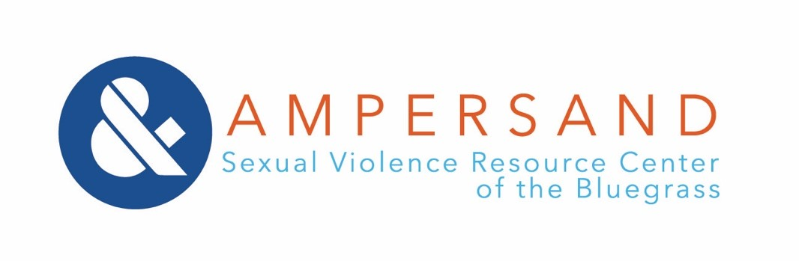
Position Description

Position: Development Coordinator

Status: Non-exempt, part-time

Summary: The Development Coordinator will be responsible for the maintenance and growth of Ampersand’s fundraising program, including individual giving, sponsorships, and special events. They will also collaborate with the Advancement team on grant writing and reporting.

Salary: $20,400-$21,000

COVID-19 considerations:
We are currently working remotely, offering Zoom counseling and advocacy to survivors, and adapting our operating procedures to protect our staff, clients, and community. We remain flexible and continue to adapt as public health guidance evolves.

To Apply:
Email cover letter, resume, and references to applications@ampersandky.org. Within your cover letter you must address your understanding of intersectionality and its importance within your professional field.
Application Deadline: Position Open Until Filled
Ampersand is an Equal Employment Opportunity employer.
No Phone Calls Please

Job Duties
Advancement
- Actively participate in setting, analyzing, and adjusting fundraising goals
- Cultivate strategies to engage Board of Directors, volunteers, and community in fundraising efforts

Donor Stewardship
- Ensure year-round engagement and stewardship of individual donors by maintaining and
- Lead efforts to identify prospective donors, including individual donors, businesses, and other groups

Special Events
- Assume a lead role in planning and executing all fundraising events in conjunction with the Development & Marketing Committee
- Work with marketing team to promote fundraising events using physical and digital advertising strategies
- Solicit major donors and sponsors for special events

General
- Participate in the establishment of a cohesive marketing strategy to be utilized across departments
- Attend full-staff meetings
- Contribute positively to the agency culture

Position Qualifications
- Understanding of and dedication to Ampersand’s mission, vision, and values
- Three years of proven, successful experience in fundraising and/or planning major events OR
- Bachelor’s degree in Philanthropy, Nonprofit Management, or closely related field
- Ability to pass a background check
- Completion of 40-hour advocacy training
- Valid driver’s license and confidential transportation
- Capable communicator with an eye for written and visual communications in particular (design or marketing experience, including ability to use design software preferred)
- Detail-oriented and proactive approach to managing time-sensitive and competing workloads

Desired Qualities
- Experience with Little Green Light or other donor database
- Exceptional interpersonal skills
- Open to and appreciative of feedback, responsive to direction and coaching
- Highly ethical, particularly in working with confidential or sensitive information
- Ability to work flexible hours, including some evenings and weekends
- Experience working in a trauma-related field

